**Commend Set Customizer**

* Open Command prompt
* Navigate to your favourite folder
* Ex: C:\Jenkins\SPFx\Nodejs\SPFx\extension
* Create new folder for app customizer
* Ex: listViewCommandSetEx1
* Create spfx solution >yo @microsoft/sharepoint

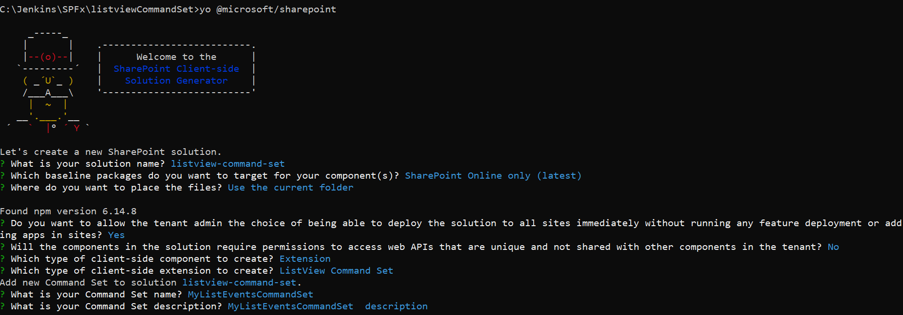

Go to code .

Open the serve.json file under config and add any list view URL ex:

https://adminspfxibm.sharepoint.com/Lists/MyProducts/AllItems.aspx

Then open **MyListEventsCommandSetCommandSet.ts** file

**Replace onListViewUpdated method**

@override

public onListViewUpdated(event: IListViewCommandSetListViewUpdatedParameters): void {

*const GetItemButton: Command = this.tryGetCommand('GetItemButton');*

*const MultipleItemButton: Command = this.tryGetCommand('MultipleItemButton');*

*const AlertMessageButton: Command = this.tryGetCommand('AlertMessageButton');*

*if(GetItemButton){*

*GetItemButton.visible = event.selectedRows.length === 1;*

*}*

*if(MultipleItemButton){*

*MultipleItemButton.visible = event.selectedRows.length > 0;*

*}*

*if (AlertMessageButton) {*

*AlertMessageButton.visible = event.selectedRows.length === 0;*

*}*

}

**Then update/replace Execute method**

public onExecute(event: IListViewCommandSetExecuteEventParameters): void {

let title = "";

switch (event.itemId) {

case 'GetItemButton':

Dialog.alert(`${event.selectedRows[0].getValueByName("Title")}`);

break;

case 'MultipleItemButton':

this._multipleitemEvent(event);

break;

case 'AlertMessageButton':

Dialog.alert(`you cliecked alert message`);

break;

case 'DeleteButton':

Dialog.prompt(`Please enter the list name to move:`).then((value:string)=>

{

title = value;

this.sendvalue(title,event);

}

);

break;

default:

throw new Error('Unknown command');

}

}

**Then add two more methods**

private **sendvalue**(title:string,event:IListViewCommandSetExecuteEventParameters)

{

let selectedtitle = event.selectedRows[0].getValueByName("Title");

Dialog.alert(title + "|" + selectedtitle);

}

private **multipleitemsevent**(event:IListViewCommandSetExecuteEventParameters)

{

let title = "";

let eventdetails ="";

for(var i=0;i<event.selectedRows.length;i++)

{

title += " " + event.selectedRows[i].getValueByName("Title") + " ";

}

Dialog.alert(`${title}`);

}

Then update the **MyListEventsCommandSetCommandSet.manifest.json** file items section

"items": {

        "GetItemButton": {

            "title": { "default": "Get Item" },

            "iconImageUrl": "icons/request.png",

            "type": "command"

        },

        "AlertMessageButton": {

            "title": { "default": "No Items Selected" },

            "iconImageUrl": "icons/cancel.png",

            "type": "command"

        },

        "MultipleItemsButton": {

            "title": { "default": "Multiple Items" },

            "iconImageUrl": "icons/cancel.png",

            "type": "command"

        },

        "DeleteButton": {

            "title": { "default": "My Delete Button" },

            "iconImageUrl": "icons/cancel.png",

            "type": "command"

        }

    }

Gulp serve and test it